CICD for Docker Kubernetes using Jenkins. Build docker images and Deploy continuously as fast as code commit.

**Tools:**

Kubernetes orchestration tool

Docker container runtime

Docker Hub container registry

Helm packaging and deployment on Kubernetes

Git version control system

Maven build tool

Sonarcube code Analysis server.

Docker File:

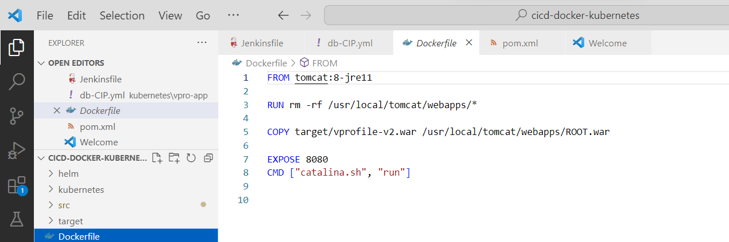

Jenkinsfile, docker file, helm folder, source code, pom file in a repository.

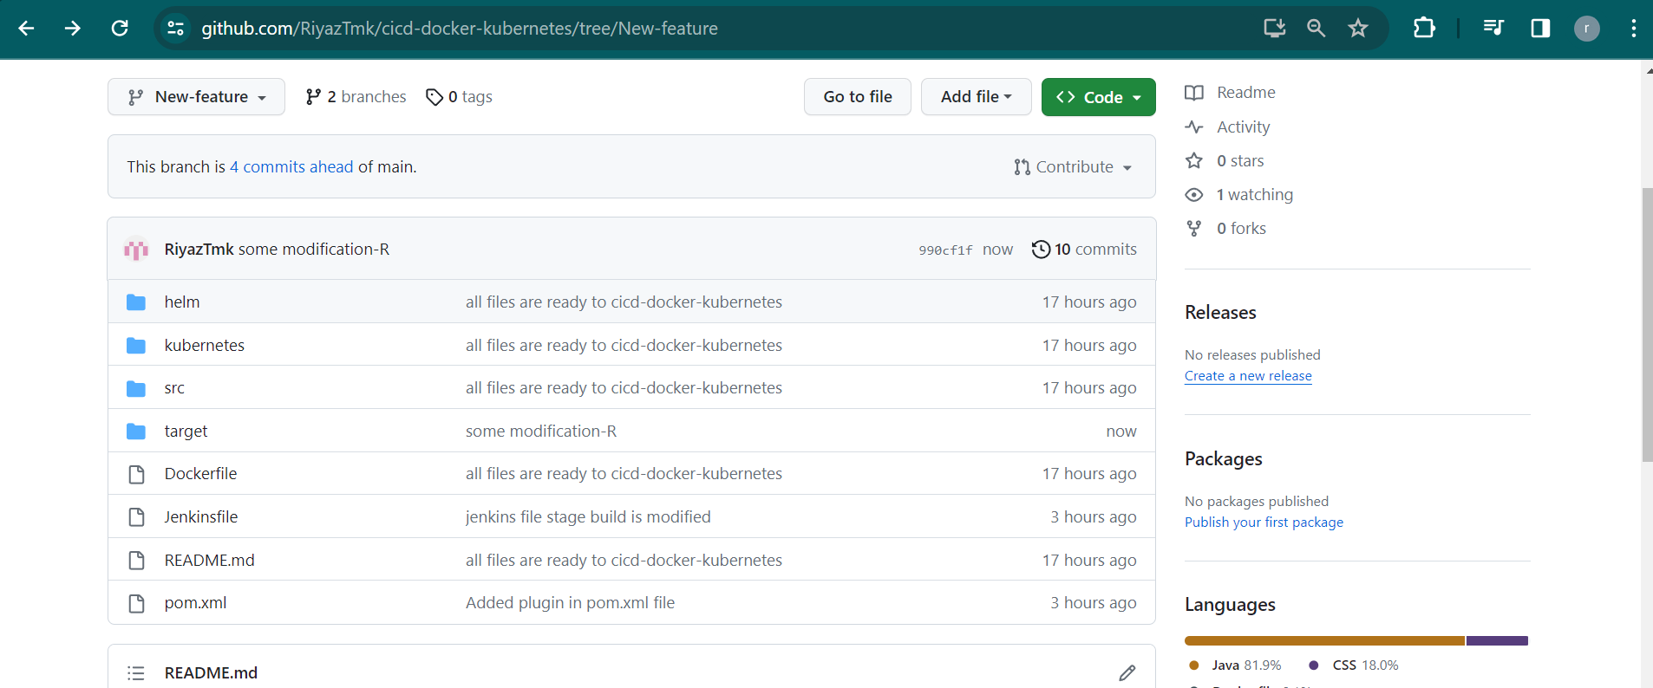

Jenkins file:

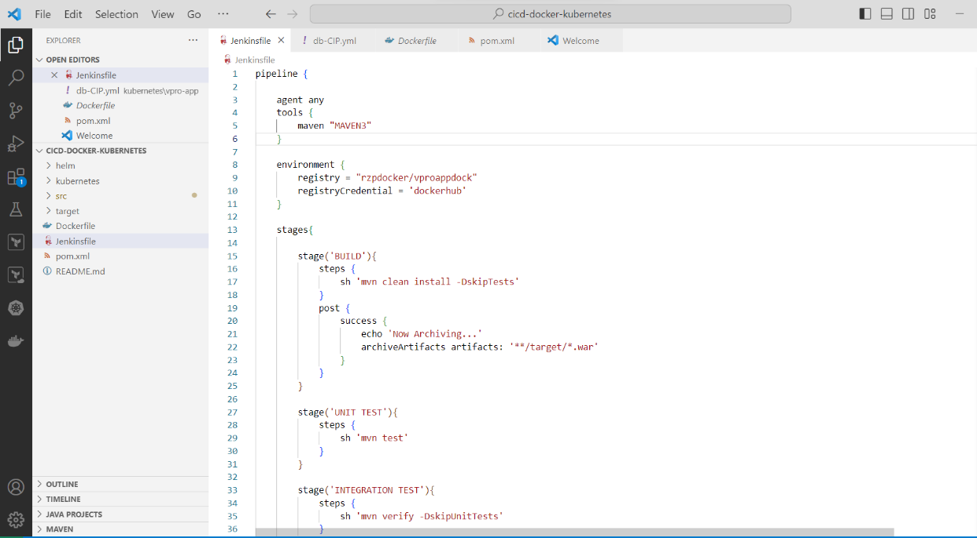

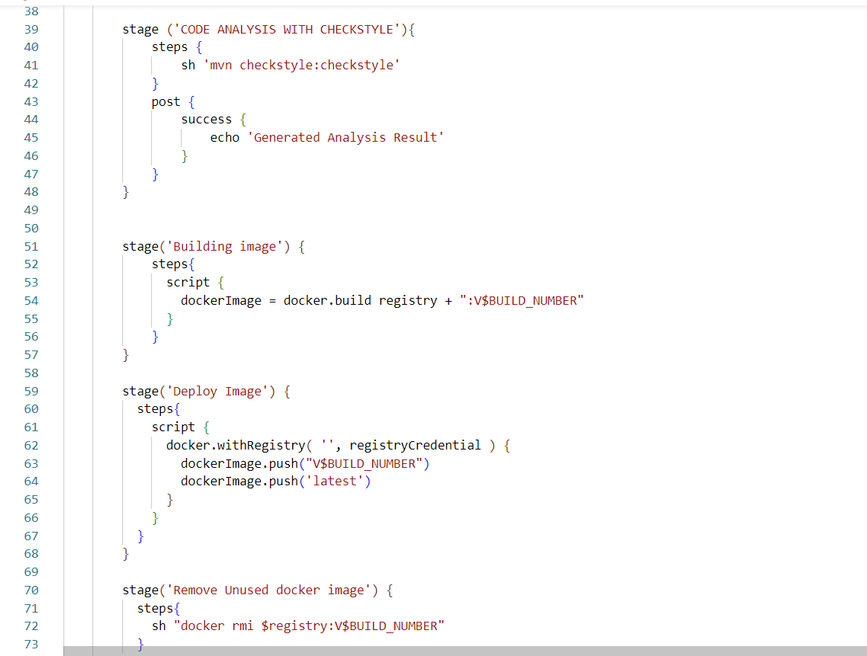

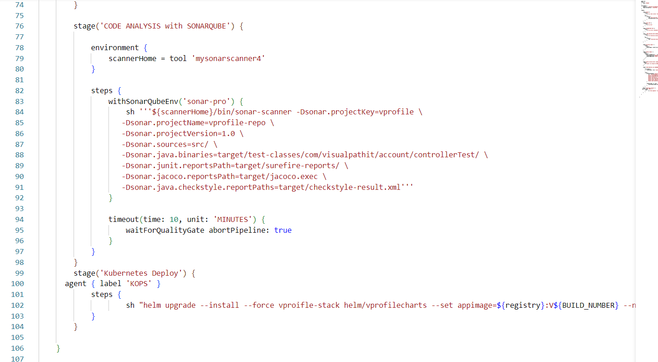

CICD pipeline:

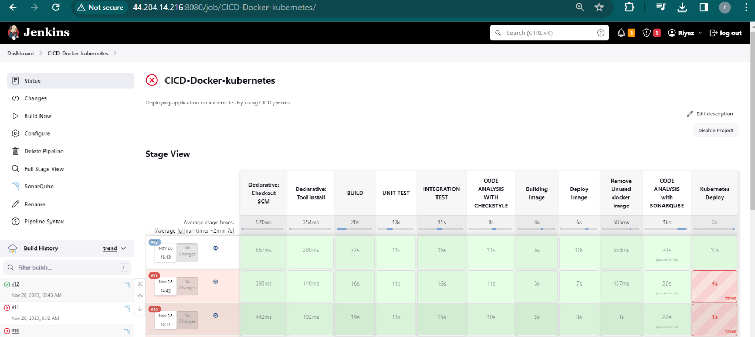

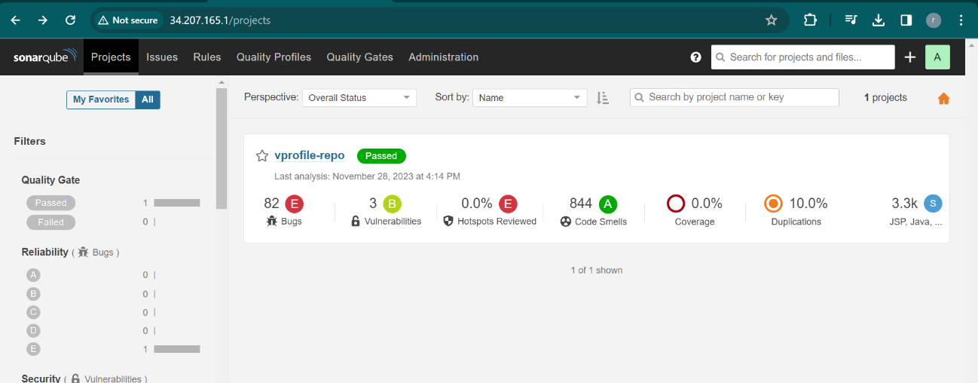

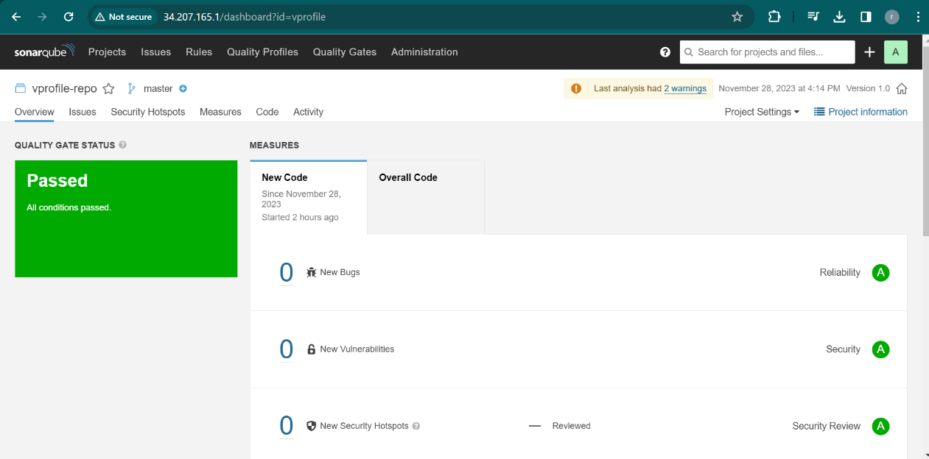

Deployments:

Services:

1.cluster IP services for internal request.

2. Load balancer service for outer request.

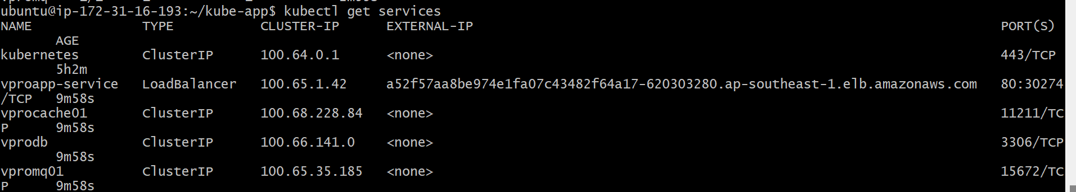

Pods:

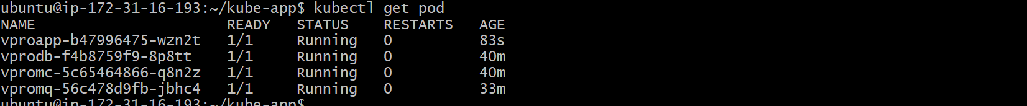

Servers:

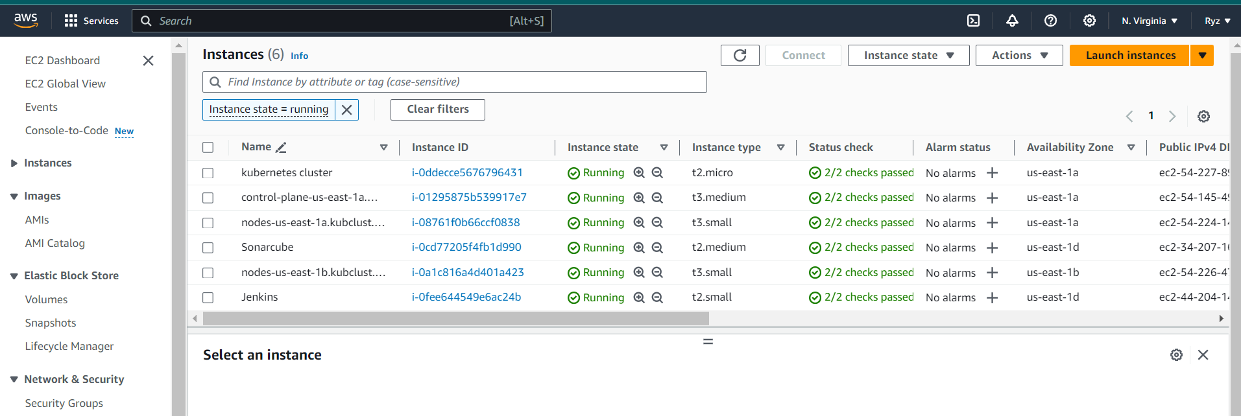

After I hit load balancer DNS website is up.

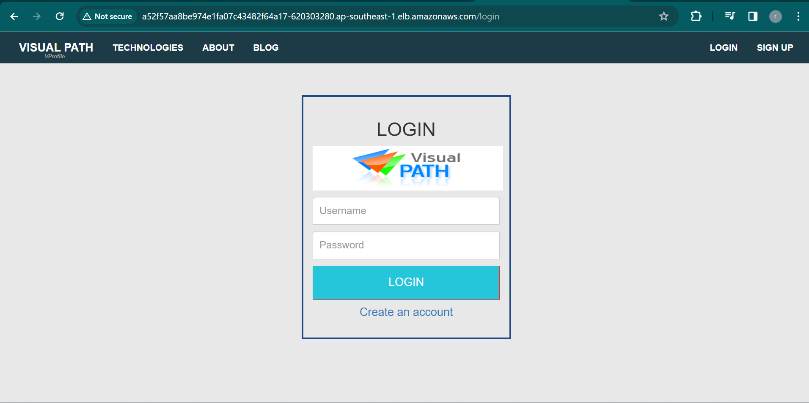

I have entered the data in the fields.

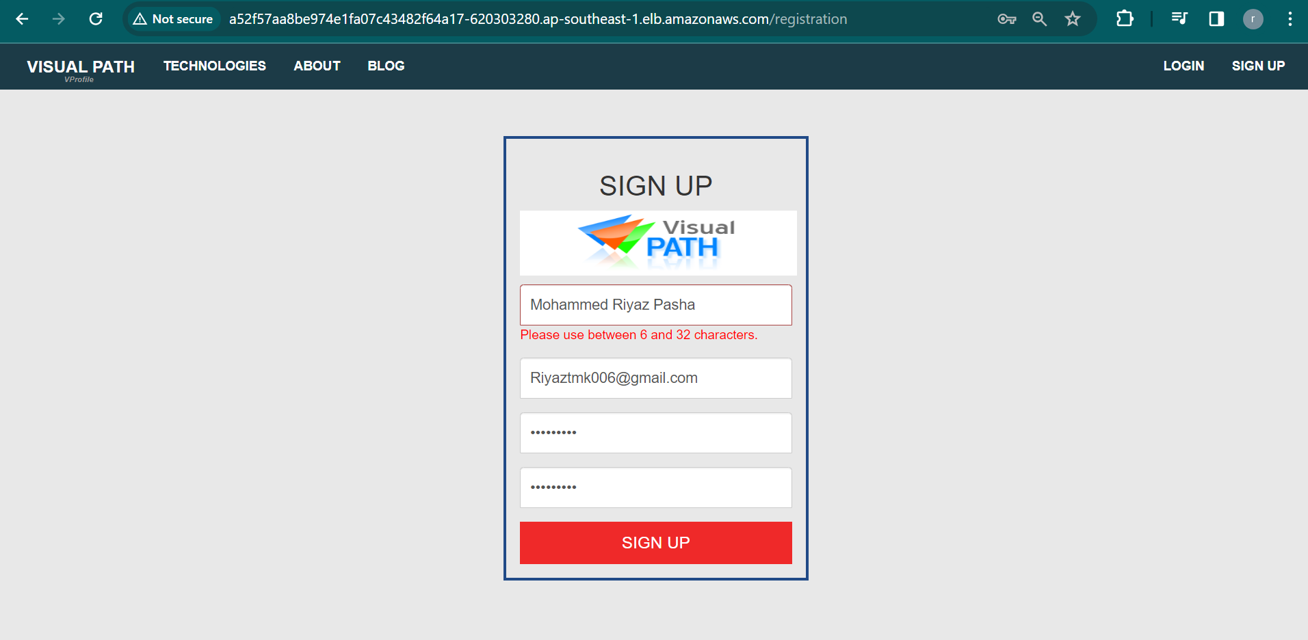

Sign up is done successfully.

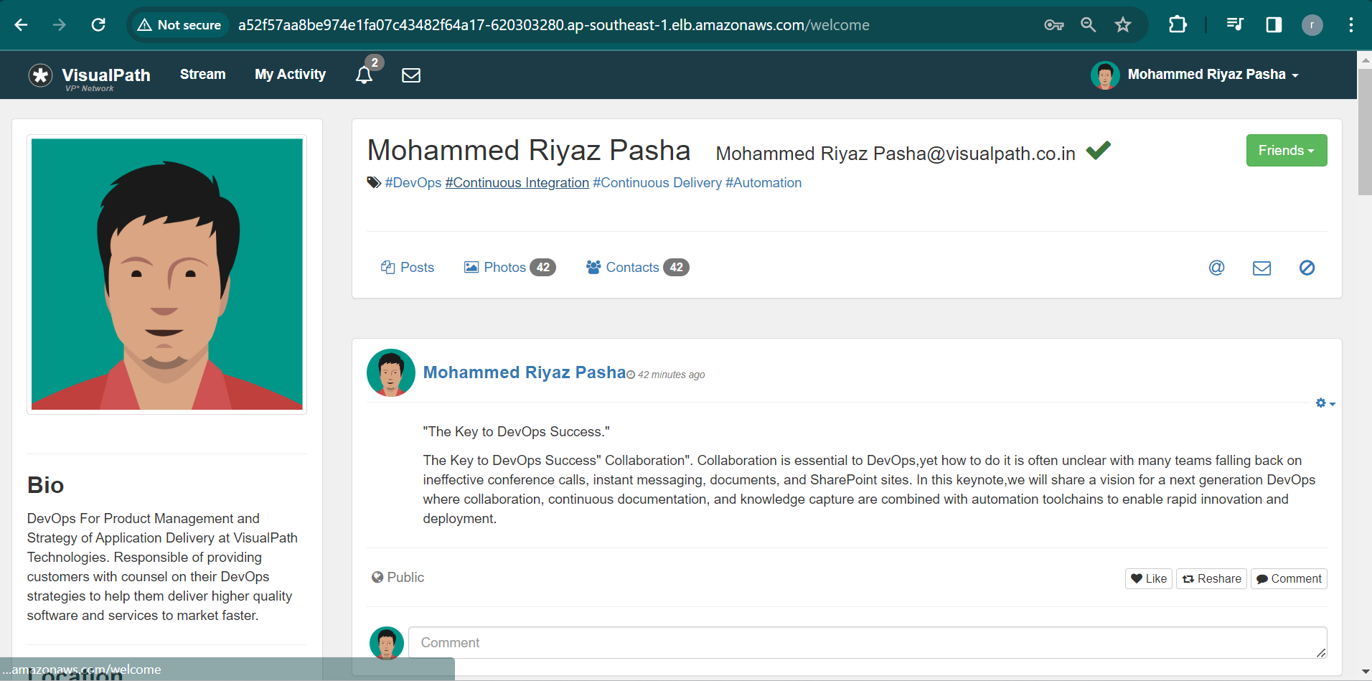

You can update profile.



